**Name:- Samreen Shaikh Roll no:- 64**

**Subject:- Big Data Analytics Date:- 10/01/2025**

**PRACTICAL - 12**

**CASSANDRA OPERATIONS**

**Q1] Create keyspace name pizza_order**

**CODE:**

CREATE KEYSPACE pizza_order WITH replication = {'class': 'SimpleStrategy', 'replication_factor': 1};

**OUTPUT:**



**Q2] Create table pizza having attributes as pizza_id[int] PK and pizza_name[text] PK as primary key,size(6 values) datatype is set,price [decimal],quantity[int],toppings datatype as map this will have sub attributes as cheesetype[text],saucetype[text] & veggies datatype as list,ratings[decimal]   
First create user defined type in cassendra of toppings and frozen the other attributes with it**

**Only for topping type will be created**

**CODE:**

CREATE TYPE toppingsdata (

cheesetype text,

saucetype text,

veggies list<text>

);

**To create table:**

CREATE TABLE pizza (

pizza_id int,

pizza_name text,

size set<text>,

price decimal,

quantity int,

toppings frozen<toppingsdata>,

ratings decimal,

PRIMARY KEY (pizza_id, pizza_name)

);

**OUTPUT:**

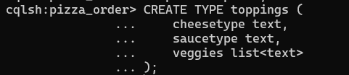

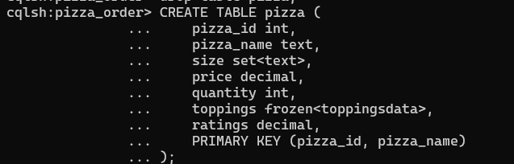

**Q3] Insert 10 records in table pizza**

**CODE:**

INSERT INTO pizza (pizza_id, pizza_name, size, price, quantity, toppings, ratings)

VALUES (1, 'Margherita', {'XS','Small', 'Medium', 'Large', 'XL', 'XXL', 'Family'}, 12.99, 10,

{ cheesetype: 'Mozzarella', saucetype: 'Tomato', veggies: ['Basil', 'Olives'] }, 4.5);

INSERT INTO pizza (pizza_id, pizza_name, size, price, quantity, toppings, ratings)

VALUES (2, 'Pepperoni', {'Small','Medium','Large','XL','XXL'}, 14.99, 15,

{ cheesetype: 'Mozzarella', saucetype: 'Tomato', veggies: ['Pepperoni'] }, 4.7);

INSERT INTO pizza (pizza_id, pizza_name, size, price, quantity, toppings, ratings)

VALUES (3, 'Vegetarian', {'Medium','Large','XL','XXL'}, 16.99, 20,

{ cheesetype: 'Mozzarella', saucetype: 'Pesto', veggies: ['Olives', 'Mushrooms', 'Peppers', 'Onions'] }, 4.8);

INSERT INTO pizza (pizza_id, pizza_name, size, price, quantity, toppings, ratings)

VALUES (4, 'Hawaiian', {'Small','Medium','Large','XL'}, 13.49, 12,

{ cheesetype: 'Cheddar', saucetype: 'Tomato', veggies: ['Ham', 'Pineapple'] }, 4.3);

INSERT INTO pizza (pizza_id, pizza_name, size, price, quantity, toppings, ratings)

VALUES (5, 'BBQ Chicken', {'Small','Medium','Large'}, 15.49, 18,

{ cheesetype: 'Mozzarella', saucetype: 'BBQ', veggies: ['Chicken', 'Onions', 'Cilantro'] }, 4.6);

INSERT INTO pizza (pizza_id, pizza_name, size, price, quantity, toppings, ratings)

VALUES (6, 'Meat Lovers', {'Medium','Large','XL'}, 17.99, 25,

{ cheesetype: 'Mozzarella', saucetype: 'Tomato', veggies: ['Pepperoni', 'Sausage', 'Bacon', 'Beef'] }, 4.9);

INSERT INTO pizza (pizza_id, pizza_name, size, price, quantity, toppings, ratings)

VALUES (7, 'Pesto Chicken', {'Small','Medium','Large'}, 16.49, 22,

{ cheesetype: 'Mozzarella', saucetype: 'Pesto', veggies: ['Grilled Chicken', 'Spinach', 'Tomatoes'] }, 4.4);

INSERT INTO pizza (pizza_id, pizza_name, size, price, quantity, toppings, ratings)

VALUES (8, 'Buffalo Chicken', {'Medium','Large','XL'}, 14.99, 14,

{ cheesetype: 'Blue Cheese', saucetype: 'Buffalo', veggies: ['Chicken', 'Celery', 'Carrots'] }, 4.2);

INSERT INTO pizza (pizza_id, pizza_name, size, price, quantity, toppings, ratings)

VALUES (9, 'Supreme', {'Small','Medium','Large','XL'}, 19.99, 35,

{ cheesetype: 'Mozzarella', saucetype: 'Tomato', veggies: ['Pepperoni', 'Sausage', 'Mushrooms', 'Peppers', 'Olives'] }, 5.0);

INSERT INTO pizza (pizza_id, pizza_name, size, price, quantity, toppings, ratings)

VALUES (10, 'Seafood', {'Medium','Large','XL'}, 20.99, 8,

{ cheesetype: 'Mozzarella', saucetype: 'White Sauce', veggies: ['Shrimp', 'Clams', 'Squid', 'Garlic'] }, 4.8);

**Insert using json format**

INSERT INTO pizza JSON '{"pizza_id": 11, "pizza_name": "Mexican Fiesta", "size": ["Medium", "Large"], "price": 18.99, "quantity": 20, "toppings": {"cheesetype": "Cheddar", "saucetype": "Salsa", "veggies": ["Jalapenos", "Onions", "Cilantro"]}, "ratings": 4.4}';

INSERT INTO pizza JSON '{"pizza_id": 12, "pizza_name": "Tropical Delight", "size": ["Small", "Medium", "Large"], "price": 15.99, "quantity": 30, "toppings": {"cheesetype": "Mozzarella", "saucetype": "Tomato", "veggies": ["Pineapple", "Red Onions"]}, "ratings": 4.6}';

**OUTPUT:**

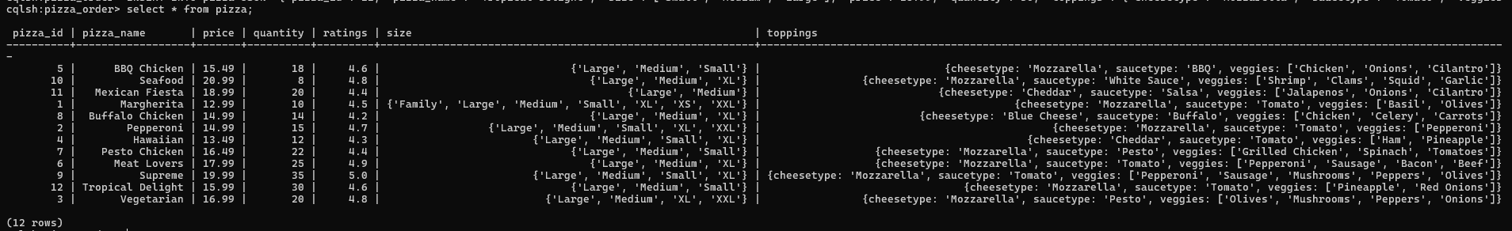

**Q4] Update cheesetype where id is 5**

**CODE:**

cqlsh:pizza_order> UPDATE pizza SET toppings = { cheesetype: 'Swiss', saucetype: 'BBQ', veggies: ['Chicken', 'Onions', 'Cilantro']} WHERE pizza_id = 5 and pizza_name='BBQ Chicken';

**OUTPUT:**



**Q5] Update the veggies subcolumn add one more value of toppings column where id = 2.**

**CODE:**

UPDATE pizza SET toppings = {

cheesetype: 'Mozzarella',

saucetype: 'Tomato',

veggies: ['Basil', 'Olives', 'Peppers']

}

WHERE pizza_id = 2 AND pizza_name = 'Pepperoni';

**OUTPUT:**



**Q6] Create another pizza1 table using map and not frozen and insert 10 records in it**

**CODE:**

CREATE TABLE pizza1 (

pizza_id int PRIMARY KEY,

pizza_name text,

size set<text>,

price decimal,

quantity int,

toppings map<text,text>,

ratings float

);

**Insert one record**

INSERT INTO pizza1 (pizza_id, pizza_name, size, price, quantity, toppings, ratings)

... VALUES (

... 1,

... 'Vegetarian Delight',

... {'Small', 'Medium', 'Large', 'Personal', 'Extra Large'},

... 9.99,

... 12,

... {'cheesetype': 'Mozzarella', 'saucetype': 'Pesto', 'veggies': 'Tomato,Olives,Onion,Spinach'},

... 4.8

... );



**Then alter the table and add one more column veggies**

cqlsh:pizza_order> ALTER TABLE pizza1 ADD veggies list<text>;

add records

-- Record 2

INSERT INTO pizza1 (pizza_id, pizza_name, size, price, quantity, toppings, veggies, ratings) VALUES (2, 'Pepperoni', {'Small', 'Medium', 'Large', 'Extra Large', 'Family'}, 12.99, 15, {'cheesetype': 'Mozzarella', 'saucetype': 'Tomato'}, ['Onion', 'Olives', 'Bell Pepper'], 4.6);

-- Record 3

INSERT INTO pizza1 (pizza_id, pizza_name, size, price, quantity, toppings, veggies, ratings)

VALUES (3, 'BBQ Chicken', {'Medium', 'Large', 'Extra Large', 'Personal'}, 14.49, 20,

{'cheesetype': 'Cheddar', 'saucetype': 'BBQ'}, ['Corn', 'Onion', 'Bell Pepper'], 4.8);

-- Record 4

INSERT INTO pizza1 (pizza_id, pizza_name, size, price, quantity, toppings, veggies, ratings)

VALUES (4, 'Veggie Supreme', {'Small', 'Medium', 'Large', 'Personal'}, 11.99, 10,

{'cheesetype': 'Provolone', 'saucetype': 'Pesto'}, ['Tomato', 'Olives', 'Spinach', 'Mushrooms', 'Onion'], 4.7);

-- Record 5

INSERT INTO pizza1 (pizza_id, pizza_name, size, price, quantity, toppings, veggies, ratings)

VALUES (5, 'Hawaiian', {'Medium', 'Large', 'Extra Large', 'Personal'}, 13.99, 8,

{'cheesetype': 'Mozzarella', 'saucetype': 'Tomato'}, ['Pineapple', 'Ham', 'Olives'], 4.5);

-- Record 6

INSERT INTO pizza1 (pizza_id, pizza_name, size, price, quantity, toppings, veggies, ratings)

VALUES (6, 'Meat Lovers', {'Medium', 'Large', 'Extra Large', 'Personal', 'Family'}, 16.99, 5,

{'cheesetype': 'Cheddar', 'saucetype': 'Tomato'}, ['Bacon', 'Sausage', 'Pepperoni'], 4.9);

-- Record 7

INSERT INTO pizza1 (pizza_id, pizza_name, size, price, quantity, toppings, veggies, ratings)

VALUES (7, 'Four Cheese', {'Small', 'Medium', 'Large', 'Extra Large'}, 12.49, 25,

{'cheesetype': 'Mozzarella', 'saucetype': 'Pesto'}, ['Spinach', 'Tomato', 'Onion', 'Olives'], 4.4);

-- Record 8

INSERT INTO pizza1 (pizza_id, pizza_name, size, price, quantity, toppings, veggies, ratings)

VALUES (8, 'Buffalo Chicken', {'Medium', 'Large', 'Extra Large', 'Family'}, 15.49, 7,

{'cheesetype': 'Gouda', 'saucetype': 'Buffalo'}, ['Spinach', 'Onion', 'Bell Pepper', 'Olives'], 4.8);

-- Record 9

INSERT INTO pizza1 (pizza_id, pizza_name, size, price, quantity, toppings, veggies, ratings)

VALUES (9, 'Seafood Special', {'Large', 'Extra Large', 'Medium'}, 17.99, 4,

{'cheesetype': 'Mozzarella', 'saucetype': 'Tomato'}, ['Spinach', 'Tomato', 'Onion'], 4.6);

-- Record 10

INSERT INTO pizza1 (pizza_id, pizza_name, size, price, quantity, toppings, veggies, ratings)

VALUES (10, 'Pesto Veggie', {'Medium', 'Large', 'Extra Large'}, 13.49, 10,

{'cheesetype': 'Parmesan', 'saucetype': 'Pesto'}, ['Spinach', 'Tomato', 'Bell Pepper', 'Onion'], 4.7);

-- Record 11

INSERT INTO pizza1 (pizza_id, pizza_name, size, price, quantity, toppings, veggies, ratings)

VALUES (11, 'Margarita', {'Small', 'Medium', 'Large'}, 9.99, 18,

{'cheesetype': 'Mozzarella', 'saucetype': 'Tomato'}, ['Basil', 'Tomato'], 4.5);

**OUTPUT:**

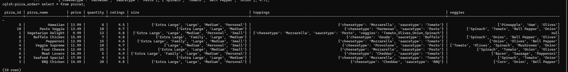

**Q7] Update using + operator**

**CODE:**

update pizza1 set veggies=veggies + ['tomato'] where pizza_id=5;

**OUTPUT:**



**Q8] Update using – Operator**

**CODE:**

update pizza1 set veggies=veggies - ['tomato'] where pizza_id=5;

**OUTPUT:**



**Q9] Use indexing to update the record**

**CODE:**

update pizza1 set veggies[1]='Ham' where pizza_id=2;

**OUTPUT:**



**Q10] Delete first record**

**CODE:**

DELETE FROM pizza1 WHERE pizza_id = 1;

**OUTPUT:**

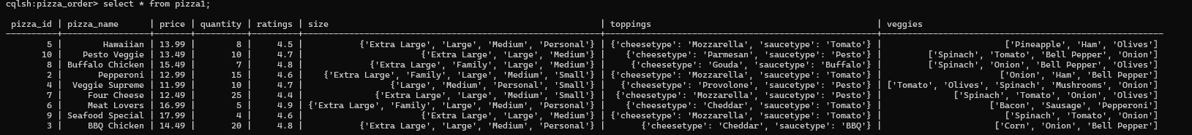

**Q11] Create new table pizza2**

**CODE:**

CREATE TABLE pizza2 (

pizza_id int PRIMARY KEY,

pizza_name text,

size set<text>,

price decimal,

quantity int,

toppings map<text,text>,

ratings float

);

INSERT INTO pizza2 (pizza_id, pizza_name, size, price, quantity, toppings, ratings)

VALUES (1, 'Pepperoni', {'Small', 'Medium', 'Large', 'Extra Large'}, 12.99, 15,

{'cheesetype': 'Mozzarella', 'saucetype': 'Tomato', 'veggies': 'Olives,Onion'}, 4.6);

INSERT INTO pizza2 (pizza_id, pizza_name, size, price, quantity, toppings, ratings)

VALUES (2, 'BBQ Chicken', {'Medium', 'Large', 'Extra Large'}, 14.49, 20,

{'cheesetype': 'Cheddar', 'saucetype': 'BBQ', 'veggies': 'Corn,Onion,Bell Pepper'}, 4.8);

INSERT INTO pizza2 (pizza_id, pizza_name, size, price, quantity, toppings, ratings)

VALUES (3, 'Veggie Supreme', {'Small', 'Medium', 'Large'}, 11.99, 10,

{'cheesetype': 'Provolone', 'saucetype': 'Pesto', 'veggies': 'Tomato,Olives,Spinach,Mushrooms,Onion'}, 4.7);

INSERT INTO pizza2 (pizza_id, pizza_name, size, price, quantity, toppings, ratings)

VALUES (4, 'Hawaiian', {'Medium', 'Large', 'Extra Large'}, 13.99, 8,

{'cheesetype': 'Mozzarella', 'saucetype': 'Tomato', 'veggies': 'Pineapple,Ham,Olives'}, *4.5);

INSERT INTO pizza2 (pizza_id, pizza_name, size, price, quantity, toppings, ratings)

VALUES (5, 'Meat Lovers', {'Medium', 'Large', 'Extra Large'}, 16.99, 5,

{'cheesetype': 'Cheddar', 'saucetype': 'Tomato', 'veggies': 'Bacon,Sausage,Pepperoni'}, 4.9);

**OUTPUT:**

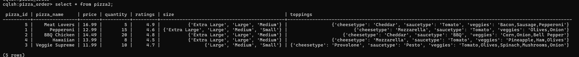

**Q12] Update and add one more record in veggies as basil in id 1**

**CODE:**

update pizza2 set toppings['veggies']='basil' where pizza_id=1;

**OUTPUT:**  


**Q13] Update pizza1 record replace index 1 with Ham in id 7**

**CODE:**

update pizza1 set veggies[1]='Ham' where pizza_id=7 IF veggies[2]='Onion';

**OUTPUT:**

